Interactions among source text, target text, and digital resources in different online naturalistic translation phases: Evidence from eye-tracking processing flow patterns

Jun Qin^{1,2} Yushu Wu^{1,2} Chunyu Kit^{1,3}

- Department of Linguistics and Translation, City University of Hong Kong, Hong Kong SAR, China.
- The two authors, J. Qin and Y. Wu contributed equally to this article.
- Enquiries should be addressed to the corresponding author, C. Kit. Address: 83 Tat Chee Avenue, KLN, Hong Kong SAR, China. Tele: (852) 3442 9310. E-mail: ctckit@cityu.edu.hk.

Abstract

Translators switch their attention across source texts (ST), digital resources (DR), and target texts (TT) during DR consultation, generating four processing flow patterns (ST-DR-ST, ST-DR-TT, TT-DR-ST, TT-DR-TT). However, little extant research has examined these patterns in the whole translation (Reaction Time - RT Phase) and its three subphases (Pre-translation, Translation, Post-translation). This study investigated how 54 L1-Chinese student translators’ flow patterns were distributed in individual phases of naturalistic English-Chinese translation using eye tracking. The results revealed that (1) In RT Phase ST-DR-ST remarkably outnumbered the rest patterns, and ST-DR-TT and TT-DR-TT significantly surpassed TT-DR-ST; (2) ST-DR-ST markedly outnumbered the remaining patterns in Pre-translation; (3) the four patterns showcased a similar distribution as RT Phase in Translation; and (4) TT-DR-TT noticeably exceeded the remaining patterns in Post-translation. The findings help understand translators’ cognitive mechanisms, translation problems, and information needs in each phase of DR-integrated translation, further contributing to translator training.
Keywords: digital resources, eye-tracking, processing flow patterns, source text, target text

Introduction
In information science, information behaviour refers to the activities an information user may engage in “when identifying his or her own needs for information, searching for such information in a way, and using or transferring that information” (Wilson, 1999, p.249). As elaborated in the model of information behaviour (Wilson, 1999), it is activated by information needs when the information user detects a gap between the information retrieved from the current task, as well as the knowledge accumulated throughout life in the long-term memory (LTM, Baddeley, 1999), and the actual solution to a task-related problem (Cui & Zheng, 2021; Miranda & Tarapanoff, 2008; Wilson, 1999). Once information needs are identified, the information user adopts information-seeking behaviour, including information searching and information relevance evaluation, in information systems and then conducts information use (Cui & Zheng, 2021; Wilson, 1999, 2000) to proceed with the problem-solving and decision-making activities (Angelone, 2010; PACTE, 2009; Wilss, 1994). These information processes, from a cognitive perspective, showcase the interactions among the information user’s LTM knowledge, the problematic situations encountered, and the information systems (Miranda & Tarapanoff, 2008).
In translation, information behaviour is featured as consultation behaviour searching for digital or online resources (Cui & Zheng, 2021), indispensable to the translation process. During translation, translators encounter translation problems such as uncertainty about source text (ST) meaning hypotheses and target text (TT) equivalent selections (Angelone, 2018; Calvo & de la Cova, 2023; Hvelplund, 2019; Newmark, 1988; Nord, 2005), which they cannot address with their LTM knowledge and ST and TT information (gaps). Subsequently, they consult internet-based and/or non-internet-based digital resources (DR) from the computer (Hvelplund, 2017) for lexical, extra-lexical, and extra-linguistic information (information searching, Cui & Zheng, 2021; Wilson, 1999, 2000). Once they confirm the information relevance to the translation problems and tasks (information relevance evaluation), they apply the obtained information to aid their ST and TT processing (information use, Cui & Zheng, 2021; Wilson, 1999, 2000). These digital resources exist in various forms, such as online monolingual or bilingual dictionaries, Internet search engines, reference works and websites, and conversion tools (Cui & Zheng, 2021; Hvelplund, 2017; Kuznik & Olalla-Soler, 2018; Shih, 2019; Sycz-Opoń, 2019; Zheng, 2014). In translation, they are massively utilized to support the situational and cognitive dimensions (Miranda & Tarapanoff, 2008) of translators’ information needs, such as ST comprehension and ST-TT meaning transfer (Angelone, 2010; Cui & Zheng, 2021; Lörscher, 1991). Moreover, DR consultation, as an auxiliary translation subtask, constitutes a considerable proportion of translators’ translation process (about 19.4% of the overall translation task time, Hvelplund, 2017).
DR consultation behaviour in translation can be captured by processing flow patterns using eye tracking, which disclose translators’ problems and information needs and further their cognitive mechanisms in the translation process. During DR consultation, translators shift their attention via gaze activities across three typical translation subtask panels, i.e., ST, DR, and TT (Cui & Zheng, 2021; Hvelplund, 2011, 2017, 2019; Sjørup, 2011; Sycz-Opoń, 2019), whose sequences constitute the so-called processing flows (Hvelplund, 2016). These processing flows follow several discernible patterns, given the condition that all the above three subtasks are entailed and ST and TT are regarded as either the departure or destination with DR recessed at the middle as a transfer position (Hvelplund, 2019): (1) From ST processing to DR consultation to ST processing (ST-DR-ST), (2) from ST processing to DR consultation to TT processing (ST-DR-TT), (3) from TT processing to DR consultation to ST processing (TT-DR-ST), and (4) from TT processing to DR consultation to TT processing (TT-DR-TT). The occurrences of these flow patterns are incurred by the aforementioned translation problems and underlying information needs, further uncovering the interplays between translators’ LTM knowledge and the retrieved ST and TT information in their working memory (WM, Baddeley, 1986, 2000, 2007; Baddeley & Hitch, 1974). Moreover, upon the activation of these patterns, translators adopt online information-seeking behaviours to retrieve different types of information like lexical information and then evaluate their relevance to the translation problems and tasks, revealing the interactions between DR information and WM information. Furthermore, the execution of the flow patterns lends support from the WM central executive (Baddeley, 2000) to perform attentional focus, division, and switching (Baddeley, 2000; Hvelplund, 2011), unveiling the third aspect of translators’ cognitive mechanisms during DR consultation.
Despite the importance of these flow patterns, scarce research has speculated on their occurrences and distributions in written translation, except for Hvelplund’s (2019) breakthrough. After categorizing 18 professional translators’ flow patterns, Hvelplund (2019) uncovered that during the whole translation the occurrence of the pattern ST-DR-TT (166) outnumbered that of TT-DR-TT (151), followed by ST-DR-ST (111) and then TT-DR-ST (82). In spite of its groundbreaking significance, we noticed three insufficient considerations: First, the interpretations for flow patterns’ occurrences are still preliminarily underpinned by descriptive statistics (Hvelplund, 2019), which await deeper explorations via inferential statistics. Second, flow patterns were examined as a static whole in the full translation process, neglecting their detailed distributions in different phases, which are termed by such names as initial orientation or pre-translation, middle drafting or translation, and revision & monitoring or post-translation (Dragsted & Carl, 2013; Jääskeläinen, 1999; Jakobsen, 2002, 2017; Jensen, 2000; Li et al., 2025). In each phase, the flow patterns, triggered by translation problems and information needs, are assumed to differ, given that individual phases entail distinctive subtasks such as ST processing in pre-translation and TT processing in translation (Angelone, 2018; Breedveld, 2002; Carl et al., 2011; Dragsted & Carl, 2013; Jakobsen, 2002; Li et al., 2025). Third, translators’ threefold cognitive mechanisms underlying these flow patterns mentioned above have not been explored in detail.
To fill the aforementioned two research gaps, this study aims to investigate the occurrences and distributions of translators’ four processing flow patterns in each translation phase (hereafter called Reaction Time (RT) Phase and its three subphases: Pre-translation, Translation, Post-translation). Further, we will explore how LTM knowledge, retrieved ST and TT information in WM, and DR information interplay during DR consultation, probe how the central executive functions during DR consultation, and interpret how translation problems and information needs incite the flow patterns in individual phases. To achieve these goals, two specific research questions are proposed as follows: (1) What are translators’ processing flow patterns in RT Phase, Pre-translation, Translation, and Post-translation? (2) Are there any salient differences among these patterns in each phase?

Methods

2.1 Participants
Initially, 56 graduate students, who were native speakers of Chinese Mandarin and studying in Hong Kong (gender: 37 females; age: 24.87 ± 3.25 years; major: 11 majoring in translation and 26 in others), were invited to participate in the translation experiment. Their eyesight was normal (or normal after eyesight correction). Additionally, they were proficient English learners with overall 6.5 scores or higher in IELTS (or equivalent) and also adept touch-typing skills in simplified Chinese. During the experiment, two of them clicked some wrong keys and interrupted the eye-tracking system by mistake. Among the 54 remaining participants, 28 translated text D and 26 rendered text E (specified in part 2.3) without time constraints. Moreover, 53 participants’ eye movements were captured from their dextral eyes, but one participant’s were recorded from his sinistral eye due to a drift correction problem.

2.2 Apparatus
The main apparatus was an eye tracker called EyeLink Portable Duo (SR Research Ltd., operating sampling rate: 2000 Hz), a Full HD BenQ screen (size: 24-inch; resolution rate: 1920 × 1080 pixels; refresh rate: 144 Hz), the software WebLink, a chinrest, and the data processing software DataViewer (DV). During the experiment, the eye tracker was installed on a tripod mount and placed about 45 cm away from the participants’ eyes, with its camera recessed about 52 cm away from their eyes. The screen displayed the translation interface (detailed in part 2.4). WebLink, used for ST display and TT production, co-functioned with the tracker to record the participants’ task time as well as their keylogging events and on-screen eye movements, once they opened the translation interface to read the ST. Moreover, the chinrest was used to stabilize the participants’ heads to maintain a 65-cm horizontal eye-to-screen distance during the whole translation process. Furthermore, DV was utilized to process the collected data.

2.3 Material selection
Before the experiment, a questionnaire was designed to investigate which register (narrative, expository, descriptive, or argumentative), genre (general, novel, scientific report, review, news, or documentary), and topic (education & culture, food & cuisine, scientific studies, fashion, sports, or traffic) the anticipated participants would like to choose for their English ST. Then, 20 Chinese English learners, whose English proficiency and learning background were controlled as similar to the formal subjects, were invited to fill in the questionnaire, which showed that the most preferred register, genre, and topic were narrative (40%), general (35%), and education (25%), respectively. Next, a general narrative text about school bullying was selected from Webpage (a subcorpus of The Corpus of Contemporary American English (COCA)), which was shortened as the original ST (text D) and further uploaded to the Text Analysis interface of COCA for word-frequency dissection. Afterwards, 20 low-frequency word strings of text D were substituted with their high-frequency synonyms to generate another ST version (text E), and its word-frequency information was also analyzed through COCA (see Table 1).
As indicated by Table 1, text D entailed 225 words, with 60%, 10%, and 14% falling into the high-, mid-, and low-frequency ranges, respectively; whereas text E comprised 224 words, of which 64%, 13%, and 9% were identified as high-, mid-, and low-frequency words, respectively. Overall, text D had lower word frequencies than text E. Furthermore, the SMOG formula (square root of (((words > = 3 syllables) / sentence) * 30) + 3, Jensen, 2009) was used to test the two texts’ readability levels, which suggested that text D (≈ 9) was more difficult to read than text E (≈ 7). Finally, 44 students were invited to rate the two texts’ vocabulary- and sentence-translation difficulty levels through a 7-point Likert scale questionnaire. The paired t-tests manifested both higher vocabulary- (t(43) = 8.6219, 95% CI: 1.95 ~ 3.14, p < 0.001) and sentence-translation (t(43) = 6.27, 95% CI: 1.32 ~ 2.58, p < 0.001) difficulty levels of text D than text E.

2.4 Translation interface design
With reference to Cui and Zheng’s (2021) translation interface, the online translation interface in our experiment was constructed based on the three main translation subtasks or areas (ST processing, TT processing, DR consultation), as indicated in Figure 1 below.
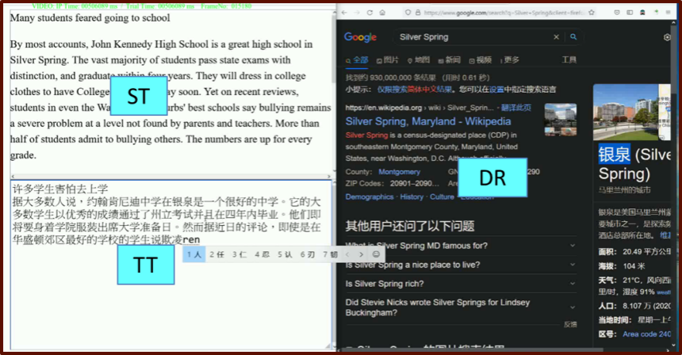
Figure 1. Online translation interface
The ST and TT areas, included in the WebLink user interface, were purposely split into equal windows with Adobe Dreamweaver through HTML and CSS coding and arranged on the left side of the translation interface. The ST area was placed on the upper window to display the English ST in Times New Roman with 1.5 line spacing and 20-pixel font size, whereas the TT area was arranged at the bottom window to write down the Chinese TT in SimSun set at the same line spacing and font size as the ST. The two windows totally covered the left half of the whole translation interface. Regarding the DR area, it shared the right half of the interface, in which the Firefox webpage defaulted by Google search was used for the participants to retrieve digital resources to solve their translation problems. After each participant finished his/her experiment, the webpage search history was deleted to prevent its potential influence on the next participant’s consultation.

2.5 Experiment procedures
All the participants registered their individual time slots (1 hour) in advance through an online questionnaire. During the experiment, after signing the written consent form, they were individually invited into a soundproof lab booth. Then, they were briefly introduced to the translation procedures: They should first read the ST, then start producing their TT, and finally revise their TT drafts. Afterwards, they were asked to acquaint themselves with the experiment equipment such as the keyboard, mouse, and input method through a practice session. Next, they performed fixation calibration and validation in which a standard 13-point grid was used. After the centroid 1-point drift correction, they opened the translation interface and started their formal translation session. After completing the experiment, they were provided with HK$100. Once all participants finished their translations, the collected data was processed in DV.

2.6 Data processing and analysis

2.6.1 Data processing
We processed the eye-movement data collected from the 54 participants in DV, including constructing interest areas (IAs) for the three subtasks, splitting the four translation phases or interest periods (IPs), filtering outlier fixations, and categorizing the four processing flow patterns.
First, an IA template was constructed based on the design of the translation interface. The whole screen (1920 × 1080 pixels), whose coordinate system origin (0, 0) was located at the top-left corner, was split into three IAs (ST, TT, DR), with the left, top, right, and bottom pixels assigned to each IA according to the following criterion: ST (0, 0, 950, 530), TT (0, 550, 950, 1080), and DR (970, 10, 1920, 1070). In doing so, the ST and TT areas were both 503,500 pixels, totalling that of the DR IA (1,007,000 pixels). Next, this template was applied to each participant’s data.
In terms of IP division, each participant’s full translation process was first processed to be the RT Phase. This period was then split into three subphases (Pre-translation, Translation, and Post-translation) according to the following six steps:
- Once the first fixation in the ST IA was observed immediately after the translation interface popped up in the 2D Temporal Graph Mode, a message called Start_Reading was added at the beginning of this fixation.
- When the first mouse event in the TT IA was detected, which was followed by continuous keylogging activities in this IA, the second message Start_Translation was tagged at the timepoint of this mouse event.
- When the last TT sentence’s full stop was found in each video recorded by WebLink during the drafting process, the third message Stop_Translation was positioned at the same timepoint of this full stop.
- When the last fixation in any of the three IAs was discovered before the WebLink recording system was terminated, the final message Stop_Proofreading was placed at the ending timepoint of the fixation.
- Steps (1) to (4) were duplicated for all 54 participants manually.
- After the four messages were tagged for all the participants, the four IPs were defined in the IP List: RT Phase started from Start_Reading and extended to Stop_Proofreading, Pre-translation from Start_Reading to Start_Translation, Translation from Start_Translation to Stop_Translation, and Post-translation from Stop_Translation to Stop_Proofreading.
After the IP definition, two kinds of data were filtered. First, fixations immediately preceding or following blinks were removed due to significantly decreased visual sensitivity before and after the blink onsets (blink suppression, Ridder & Tomlinson, 1995; Volkmann et al., 1980). Second, fixations less than 80 milliseconds (ms) were discarded because they were too short to help translators gain useful information (Qingrong & Yan, 2012; Gerganov, 2007; Reingold et al., 2010; Slattery et al., 2011).
Following the previous step, the eye-tracking data of Pre-translation, Translation, and Post-translation was exported into three separate IA reports. Based on the IA fixation sequences in each report and our observations in the recorded videos, we categorized and counted the four processing flow patterns (ST-DR-ST, ST-DR-TT, TT-DR-ST, TT-DR-TT) for each participant in the three IPs. Given the fact that some participants sometimes randomly looked at the DR area without consulting the online resources, verification and deletion of some patterns were conducted based on the fixations and keylogging events. Furthermore, individual flow patterns’ counts in the three IPs were added to be their corresponding total ones in RT Phase.

2.6.2 Data analysis
Both descriptive and inferential analyses were conducted in Rstudio (R Core Team, 2025). First, the descriptive statistics (mean: M; standard deviation: Sd; sum: Sum) of the four processing flow patterns were analyzed to describe their overall occurrences in each translation phase. Following the descriptive analysis, inferential statistics (independent variable: type of processing flow patterns; dependent variable: occurrences or count of the four processing flow patterns) were examined, with Kruskal-Wallis tests conducted to analyze whether there were significant differences among the four patterns’ occurrences. If differences were observed, pairwise Wilcoxon tests were conducted to further disclose the specific differences, with the p values adjusted through the Bonferroni method to control Type Ⅰ errors in multiple comparisons.

Results

Processing flow patterns in RT Phase
The descriptive statistics of the four processing flow patterns in RT Phase, as presented in Table 2, indicate that ST-DR-ST occurred most frequently (M = 27.37, Sd = 19.22, Sum = 1478), accounting for 42.60% of the total four patterns. TT-DR-TT (M = 17.93, Sd = 13.52, Sum = 968) and ST-DR-TT (M = 12.81, Sd = 6.08, Sum = 692) were performed less frequently than the first pattern, the ratios of which were 27.90% and 19.90%, respectively. The least occurring pattern was TT-DR-ST (M = 6.13, Sd = 3.93, Sum = 331), the percentage of which was only 9.50%.
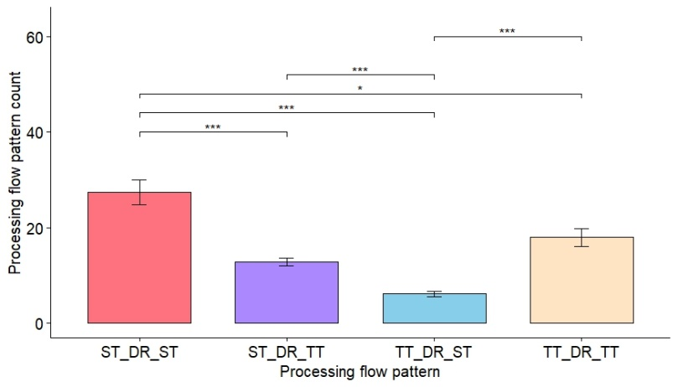
Figure 2. Differences of processing flow patterns in RT Phase
(Alt text: The bar chart displays processing flow pattern count on the y-axis with vertical error bars indicating variability against four types, i.e., ST-DR-ST, ST-DR-TT, TT-DR-ST, and TT-DR-TT, on the x-axis. The significance levels, suggested by “*” (“*”: p < 0.05, “**”: p < 0.01, and “***”: p < 0.001), were adjusted through the Bonferroni method to prevent Type Ⅰ errors in multiple comparisons.)
The Kruskal-Wallis test showed that the four patterns’ occurrences reached significant differences (χ² = 79.31, df = 3, p < 0.001) in RT Phase. The pairwise Wilcoxon tests further demonstrated that ST-DR-ST remarkably outnumbered ST-DR-TT (p < 0.001), followed by TT-DR-ST (p < 0.001). Additionally, ST-DR-ST noticeably surpassed TT-DR-TT (p = 0.022). Furthermore, TT-DR-TT was observed more frequently than TT-DR-ST (p < 0.001). However, no marked difference between TT-DR-TT and ST-DR-TT (p = 0.309) was observed (see Figure 2).
Before analyzing the four patterns’ phase-specific occurrences and distributions, Fig. 3 sketches the overall landscape of their distributions in percentages in Pre-translation, Translation, and Post-translation.
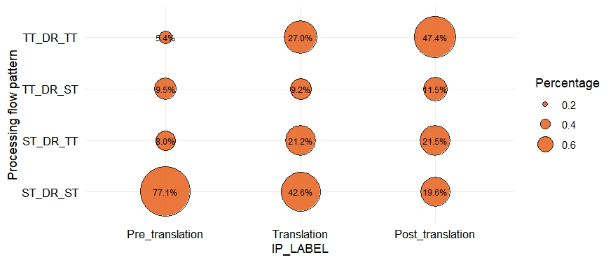
Figure 3. Overall sketch of the four patterns’ distributions in the three phases
(Alt text: The x-axis presents the labels of the three translation phases, and the y-axis shows the processing flow pattern types. The percentages of different patterns in each phase were calculated through the formula “the occurrence of one pattern in one phase / the total occurrences of all four patterns in this phase”.)
Figure 3 illustrates two prominent points regarding the four patterns’ occurrences: First, they were unevenly distributed in each phase. Second, the same patterns’ occurrences showed dynamic changes across the three phases: The percentages of ST-DR-ST and TT-DR-TT manifested the greatest changes across the three phases, followed by ST-DR-TT. Compared with the above three patterns, the percentages of TT-DR-ST suggested the fewest changes.

Processing flow patterns in Pre-translation
As indicated by the means of the four patterns (see Table 3), in Pre-translation digital resources were rarely consulted by the participants, with the latter three patterns executed less than one time on average. The pattern ST-DR-ST (M = 4.98, Sd = 4.99, Sum = 269) was mostly performed, accounting for a substantial percentage (77.10%) of the total. Contrastingly, the remaining three patterns TT-DR-ST (M = 0.61, Sd = 0.74, Sum = 33), ST-DR-TT (M = 0.52, Sd = 1.19, Sum = 28), and TT-DR-TT (M = 0.35, Sd = 0.73, Sum = 19) were seldom conducted, which only occupied 9.50%, 8.00%, and 5.40% of the total occurrences, respectively.
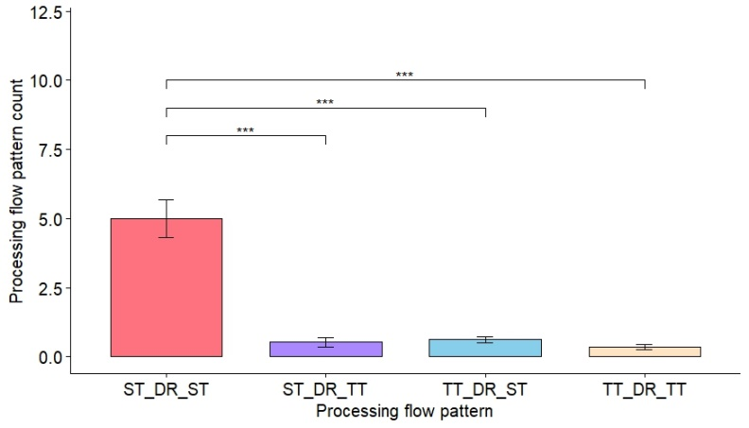
Figure 4. Differences of processing flow patterns in Pre-translation
(Alt text: The bar chart presents processing flow pattern count on the y-axis with vertical error bars indicating variability against four types on the x-axis. The significance levels, as indicated by “*”, were adjusted through the Bonferroni method.)
Notable differences among the four patterns’ occurrences were unveiled by the Kruskal-Wallis test (χ² = 91.86, df = 3, p < 0.001) in Pre-translation. Specifically, ST-DR-ST markedly outnumbered the other three patterns, as evinced by the pairwise Wilcoxon tests (p < 0.001). However, there was no significant difference between ST-DR-TT and TT-DR-ST (p = 0.325), between ST-DR-TT and TT-DR-TT (p = 1.000), or between TT-DR-ST and TT-DR-TT (p = 0.094).

3.3 Processing flow patterns in Translation
As shown in Table 4, in Translation ST-DR-ST (M = 20.50, Sd = 15.19, Sum = 1107) was performed most frequently, the percentage of which was 42.60%. The following pattern was TT-DR-TT (M = 13.00, Sd = 12.17, Sum = 702), and it accounted for 27.00% of the total consultation occurrences. The third frequent pattern was ST-DR-TT (M = 10.22, Sd = 5.16, Sum = 552), whose percentage was 21.20%, followed by the least occurring pattern TT-DR-ST (M = 4.41, Sd = 3.23, Sum = 238), which only accounted for 9.20% of the total.
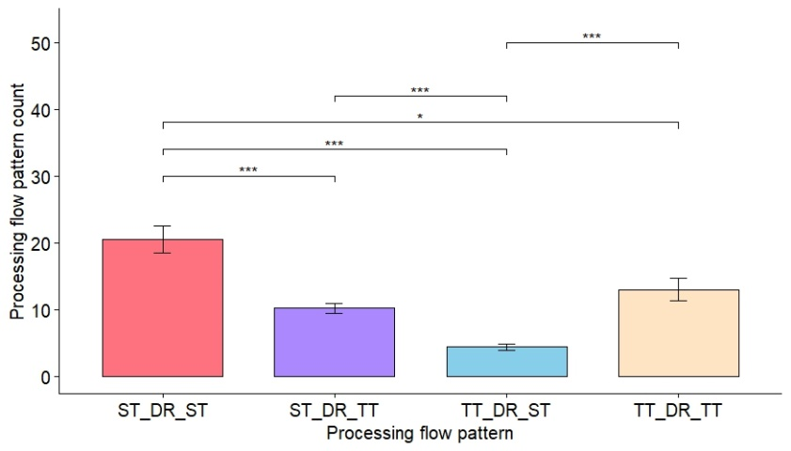
Figure 5. Differences of processing flow patterns in Translation
(Alt text: The bar chart shows processing flow pattern occurrences on the y-axis with vertical error bars suggesting variability against four types on the x-axis. The Bonferroni method was used to adjust the comparison significance levels between different types.)
The four patterns’ occurrences significantly differed in Translation, as revealed by the Kruskal-Wallis test (χ² = 68.731, df = 3, p < 0.001). The pairwise Wilcoxon tests further uncovered a distribution similar to that in RT Phase: The most common pattern, ST-DR-ST, notably outnumbered ST-DR-TT (p < 0.001), TT-DR-ST (p < 0.001), and TT-DR-TT (p = 0.016). In addition, the occurrences of ST-DR-TT and TT-DR-TT were significantly more than that of TT-DR-ST (p < 0.001). Moreover, no statistical difference between ST-DR-TT and TT-DR-TT was disclosed by the pairwise Wilcoxon tests (p = 1.000).

3.4 Processing flow patterns in Post-translation
The descriptive statistics (see Table 5) suggest that the most frequently occurring pattern in Post-translation was TT-DR-TT (M = 4.57, Sd = 4.67, Sum = 247), and it took a considerable proportion (47.40%) of all patterns. The following two patterns, ST-DR-TT (M = 2.07, Sd = 2.30, Sum = 112) and ST-DR-ST (M = 1.89, Sd = 2.63, Sum = 102), got very close in terms of their percentages (21.50% and 19.60% respectively). The least occurring pattern was TT-DR-ST (M = 1.11, Sd = 1.31, Sum = 60), which only accounted for 11.50%.
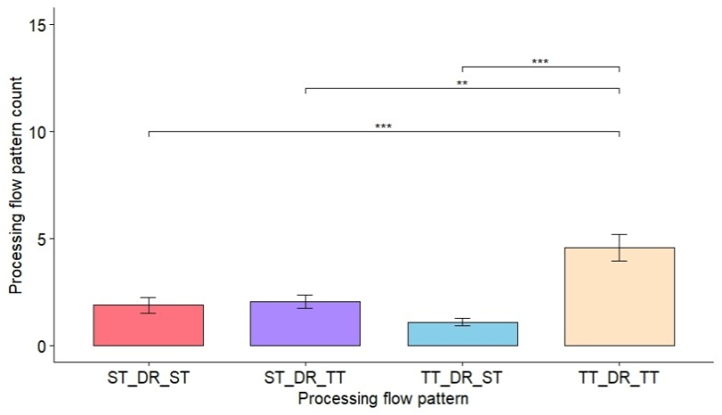
Figure 6. Differences of processing flow patterns in Post-translation
(Alt text: The bar chart demonstrates processing flow pattern count on the y-axis with the variability indicated by vertical error bars against four types on the x-axis. The comparison significance levels between different types were adjusted through the Bonferroni method.)
The Kruskal-Wallis test demonstrated significant differences among the four patterns’ occurrences (χ² = 34.90, df = 3, p < 0.001). To be more specific, the most frequently occurring pattern TT-DR-TT outnumbered TT-DR-ST (p < 0.001), ST-DR-ST (p < 0.001), and ST-DR-TT (p = 0.002), as suggested by the pairwise Wilcoxon tests. However, there was no statistical difference between ST-DR-ST and ST-DR-TT (p = 1.000), between ST-DR-TT and TT-DR-ST (p = 0.234), or between ST-DR-ST and TT-DR-ST (p = 1.000).

Discussion
This study produces robust evidence that all four processing flow patterns occurred differently in RT Phase, Pre-translation, Translation, and Post-translation. These patterns were triggered by the participants’ translation problems (Angelone, 2018; Calvo & de la Cova, 2023; Cui & Zheng, 2021; Dragsted & Carl, 2013; Hvelplund, 2019; Newmark, 1988; Nord, 2005) and information needs (Angelone, 2010; Cui & Zheng, 2021; Miranda & Tarapanoff, 2008; Wilson, 1999, 2000). To further the preliminary discussion by Hvelplund (2019), we first refine his interpretations and decipher our new online observations.
Regarding ST-DR-ST, it showed the participants’ uncertainty about their constructed ST meaning hypotheses or other ST comprehension problems they encountered, so they shifted their attention to the digital resources for help (Angelone, 2010; Cui & Zheng, 2021; Hvelplund, 2019). Afterwards, they returned to the ST to “reconfirm a meaning hypothesis (of the ST) with the new information from the recent digital resource consultation” (Hvelplund, 2019, p.520) or reconstruct a new ST meaning hypothesis. As for ST-DR-TT, the participants were “likely to have arrived at a plausible meaning hypothesis of a source text item aided by the digital resource”, which permitted them “to work on the target text, possibly formulating a translation solution in the target language” (Hvelplund, 2019, p.520). In this situation, the digital resources were used to conduct ST-TT meaning transfer (Angelone, 2010; Cui & Zheng, 2021; Lörscher, 1991). For TT-DR-ST, it demonstrated that the participants were “currently attempting to produce a TT rendition of an ST item, aided by a digital resource. However, the successful translation was interrupted due to comprehension or reformulation issues”, and this pattern may be “an indicator of insecurity and problems at the level of (ST) comprehension as well as (TT) production” (Hvelplund, 2019, p.520). Therefore, TT-DR-ST was related to ST comprehension and TT production (Angelone, 2010; Cui & Zheng, 2021;). Finally, TT-DR-TT indicated that the participants “may consult digital resources to identify potential target language equivalents or to reconfirm a translation choice” (Hvelplund, 2019, p.520), concerning ST-TT meaning transfer and TT production. Additionally, the participants’ keylogging activities following DR consultation (e.g., deletion of some existing TT drafts, followed by insertion of some new contents) evinced that TT-DR-TT also involved TT verification in Translation (online revision) and Post-translation (end revision, Dragsted & Carl, 2013; Li et al., 2025).
The abovementioned four flow patterns and their incurring problems and information needs disclose the interplays between the participants’ WM information retrieved from the ST and TT and LTM knowledge, the interactions between WM information and DR information, and the central executive’s pivotal role during DR consultation. The translators’ WM visuospatial sketchpad (VSSP) continuously retrieved ST and TT visual information such as word orthographies, and the phonological loop (loop) obtained ST and TT verbal and acoustic information like word phonemes (Baddeley, 2000, 2007). Simultaneously, the WM crystallized systems unceasingly extracted relevant visual semantics and language knowledge from the LTM (Baddeley, 2000, 2007). The WM information about the ST and TT and the LTM knowledge were expressed into the episodic buffer (buffer) to generate “a unitary episodic representation” (p.417) or “new cognitive representations” (Baddeley, 2000, p.421). If the WM information did not match LTM knowledge, the generation of cognitive representations was interrupted, and translation problems and information needs were triggered, further eliciting consultation behaviour in the DR window. After the DR information, such as orthographic and lexical information about the searched ST and TT items, was processed via VSSP and the loop, it was expressed to the buffer. If the DR information matched the WM information about the ST and TT and LTM knowledge, information relevance was achieved, and the three were integrated to form a new cognitive representation as a solution to the encountered translation problem. Once the DR consultation was activated, the central executive of translators’ working memory performed attentional focus, division, and switching (Baddeley, 2007; Hvelplund, 2011) to efficiently allocate varying amounts of attention to different subtasks. This component first initiated attentional switching to shift the participants’ attention from the current ST/TT subtask to DR consultation (attentional switching), then maintained their attention in the DR area to comprehend the retrieved online information (attentional focus), and finally regressed to the original or proceeded to the next ST/TT subtask (attentional switching). Simultaneously, it allocated the participants’ attention properly in order to finish the translation task (attentional division). Once all translation problems were solved and the whole translation task was completed, the above processes were terminated.
Taking LTM knowledge, WM information, and DR information into consideration together, the cognitive essences of individual translation problems and information needs might be uncovered. Translation problems are mismatches/unstable matches and distances between LTM knowledge and WM information about ST/TT: (1) Unknown ST elements or uncertain ST meaning hypotheses: mismatches or unstable matches between LTM knowledge and ST information in WM, (2) ST-TT meaning transfer: distances among LTM knowledge, ST information, and TT information in WM, (3) TT production: mismatches between LTM knowledge and TT information in WM, and (4) insecurity of TT production: unstable matches between LTM knowledge and TT information in WM. After identifying these problems, the situational and cognitive dimensions of information needs for ST comprehension, ST-TT meaning transfer, and TT production/verification were initiated to search for DR information, which constitutes the solutions to cope with the mismatches or unstable matches or bridge the distances between LTM knowledge and WM information about ST and TT.
From a pedagogical perspective, the above interpretations suggest the importance of accessible digital resources while ensuring their moderate and efficient use in the translation process. On the one hand, digital resources consulted properly help translators tackle their translation problems and meet their information needs, so their accessibility should be guaranteed in the naturalistic translation process. Given this, translators should enhance their instrumental sub-competence (PACTE, 2003) or technological competence (Wei et al., 2026) to use information technologies to retrieve various online resources. On the other hand, DR information searching and relevance evaluation are effort-demanding, and the effort for executing unceasing attentional focus, division, and switching during DR consultation is progressively decreasing over time, which might engender a slowdown effect on translators’ cognitive processing (Baddeley, 2007; Hvelplund, 2019). Hence, excessive and inefficient DR consultation should be prevented.

4.1 Various translation problems and information needs in RT Phase
In RT Phase, all four patterns were observed, demonstrating that the participants encountered various problems throughout the whole translation process, with the occurrences of ST-DR-ST, TT-DR-TT, ST-DR-TT, and TT-DR-ST sequentially decreased (see part 3.1). In our results, the least occurrence of TT-DR-ST echoed Hvelplund’s (2019) findings, yet the rest three patterns had diverged distribution. We attributed such divergency to the participants’ vocabulary pools (Kafipour & Jahansooz, 2017; Kim, 2006; Newmark, 1988), pre-existing knowledge (Carrell & Eisterhold, 1983; Wilson, 1999, 2000), and translation expertise and sub-competences (Hurtado, 2015; PACTE, 2003). The participants in Hvelplund’s study were professional translators with larger vocabulary pools, sufficient pre-existing knowledge, and more translation expertise and sub-competences in their LTM, contributing to fewer gaps between LTM knowledge and WM information about the ST. Hence, they focused more on and had more translation problems with and information needs of TT production than ST comprehension, resulting in more occurrences of ST-DR-TT and TT-DR-TT than that of ST-DR-ST. In contrast, our study recruited student translators who fell short in these translation sub-competences, felt insecure about their ST meaning hypotheses (Carl & Dragsted, 2012; Gile, 1995), and encountered more ST comprehension problems, engendering more ST-DR-ST than TT-DR-TT and ST-DR-TT. Moreover, the occurrence of ST-DR-ST remarkably outnumbered that of ST-DR-TT, TT-DR-ST, and TT-DR-TT, and the occurrences of ST-DR-TT and TT-DR-TT saliently surpassed that of TT-DR-ST. The results constitute compelling evidence for unprofessional translators’ greatest struggle in unknown ST elements or uncertain ST meaning hypotheses, followed by production of TT items, insecurity of TT production, or ST-TT meaning transfer.
Further, ST-DR-TT, TT-DR-ST, and TT-DR-TT surprisingly appeared in Pre-translation, which againsts the expected overall sketch of the four patterns (see Figure 7). However, based on our instructions provided to the participants and previous studies (Dragsted & Carl, 2013; Jääskeläinen, 1999; Jakobsen, 2002, 2017; Jensen, 2000), the three patterns should not occur, since the participants were simply comprehending the ST. We treat these cases as translators’ self-assertive outliers in Pre-translation.
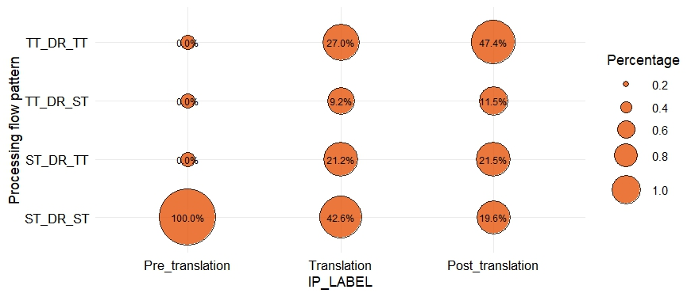
Figure 7. Expected sketch of the distribution of the four patterns in three phases
(Alt text: The x-axis displays the labels of the three translation phases, and the y-axis indicates the processing flow pattern types. The percentages of different patterns in each phase were calculated through the same formula as RT Phase, but the occurrences of ST-DR-TT, TT-DR-ST, and TT-DR-TT in Pre-translation were regarded as “0”.)
The above explanations underscore improving translators’ bilingual and extralinguistic sub-competences, as elaborated in the Translation Competence model (PACTE, 2003). First, translators should expand their vocabulary pools (lexical knowledge, PACTE, 2003) and enrich their grammatical-lexical knowledge about syntax and textual knowledge about texture (PACTE, 2003; Presas, 2012). Second, they should broaden their extralinguistic knowledge about the source language cultures (Olalla-Soler, 2019; PACTE, 2003). These two measures help reduce ST comprehension problems, contributing to fewer ST-DR-ST patterns in the whole translation process.

4.2 ST comprehension in Pre-translation
In Pre-translation, all four patterns were observed, and ST-DR-ST occurred most frequently, significantly outnumbering other patterns (ST-DR-TT, TT-DR-ST, TT-DR-TT) which should not be shown in Pre-translation. ST-DR-ST’s most frequent occurrence indicates that the participants mainly had ST comprehension problems due to gaps between LTM knowledge and ST information in WM. Moreover, due to different translation styles (e.g., quick planners and head-starters; Dragsted & Carl, 2013; Li et al., 2025) and limited translation expertise and sub-competences (Hurtado, 2015; PACTE, 2003), some participants started to draft their TT immediately after reading the first ST sentence or even directly started to generate their TT right away once the translation interface popped up, and conducted DR consultations. After they drafted the very first TT sentence or the title, they returned to the ST window, once they realized their behaviour went against our translation instructions prior to the experiment.
Practically, the above findings and interpretations highlight fostering translators’ bilingual and extralinguistic sub-competences and their knowledge of translation sub-competence in DR-enabled translation. Translators’ bilingual and extralinguistic sub-competences should be improved to reduce ST-DR-ST occurrences (see part 4.2). Moreover, their knowledge of translation sub-competence about translation procedures should be strengthened to avoid inappropriate translation styles such as quick planners and head-starters, eliminating outlier ST-DR-TT, TT-DR-ST, and TT-DR-TT in Pre-translation.

4.3 ST comprehension, ST-TT meaning transfer, and TT production/verification in Translation
The occurrences of the four patterns in Translation almost replicated those in RT Phase, with each occurring frequently (see parts 3.1 and 3.3), suggesting two points of information about the participants’ translation problems: First, most of their translation problems in the whole translation process were incurred in Translation. Second, the encountered problems in this phase involved various aspects, including comprehending the ST or reconfirming the ST meaning hypotheses, finding plausible equivalent TT words/phrases for the corresponding ST items, producing the TT, and reconfirming the TT drafts. Moreover, the four patterns manifested the same differences as those in RT Phase, indicating that, similar to what they did in the full translation process, the translators consulted the digital resources mainly to aid their ST comprehension, ST-TT transfer of meaning, TT production, and TT verification (online revision) in a sequentially decreasing manner.

4.4 ST-TT meaning transfer and TT production/verification in Post-translation
In the Post-translation, the occurrences of all four flow patterns decreased, manifesting that the majority of translators’ problems were solved in Pre-translation and Translation. Additionally, TT-DR-TT occurred most frequently, so Post-translation might mainly entail ST-TT meaning transfer and TT production or verification. To detail the participants’ problems and information needs while executing TT-DR-TT, TT verification occurred more often in Post-translation, compared to ST-TT meaning transfer and TT production more frequently involved in Translation. In Translation, translation problems centered on finding proper TT equivalents for certain ST items and retrieving DR information to aid TT production, indicated by many newly-added alphanumeric keylogging events following DR consultation. TT verification (online revision) occurred less frequently than ST-TT meaning transfer and TT production, as suggested by much fewer deletion keyloggings after DR consultation. Contrastingly, in Post-translation, the translators already completed the main body of their translation drafts, so they consulted the DR mainly to verify or revise TT drafts (end revision), as evinced by increased deletion keylogging events in the TT window after their DR consultation.
For pedagogical implications, translator training should enhance trainees’ bilingual and extralinguistic sub-competences. Measures include expanding their lexical, grammatical-lexical, and textual knowledge about the source and target languages, bicultural knowledge about the source and target cultures, and encyclopaedic knowledge about the world (PACTE, 2003). In doing so, they can minimize uncertain ST meanings and insecure TT productions in Pre-translation and Translation, further reducing their TT verification and DR consultation in the Post-translation phase.

Conclusion
This study examined the occurrences and distributions of 54 L1-Chinese student translators’ four processing flow patterns during their digital resource consultation in the four phases of the naturalistic English-Chinese translation process. The results revealed that the four patterns were unevenly distributed and manifested significant differences in each phase: First, in RT Phase, ST-DR-ST markedly outnumbered ST-DR-TT, TT-DR-ST, and TT-DR-TT, and ST-DR-TT and TT-DR-TT remarkably surpassed TT-DR-ST. Second, in Pre-translation, ST-DR-ST was notably more than the rest three patterns. Third, in Translation, ST-DR-ST occurred more frequently than ST-DR-TT did, followed by TT-DR-ST; ST-DR-ST was more frequently observed than TT-DR-TT; and ST-DR-TT and TT-DR-TT significantly outnumbered TT-DR-ST. Finally, in Post-translation, the occurrence of TT-DR-TT was more frequent than the occurrences of the other three patterns.
Following Hvelplund (2019), this study further compared the four patterns’ occurrences and distributions and elaborated on how phase-dependent distinctive translation problems and information needs incurred varied patterns in each phase. Moreover, the conditional triggers of these patterns unveil how translators’ LTM knowledge, WM information about the ST and TT, and DR information interplayed with each other and how working memory’s central executive functioned during DR consultation in naturalistic translation. Taken together, translator training should underscore strengthening translators’ bilingual, extralinguistic, and instrumental sub-competences, as well as their knowledge of translation sub-competence, to cope with the problems and information needs in DR-integrated translation.
Admittedly, this study is flawed in that it explored the underlying reasons for the four patterns’ distributions based on the participants’ eye-tracking and keylogging behavioural data, which, however, cannot provide qualitative evidence for tracing back the participants’ real struggles and solutions. To cope with this problem, future research can triangulate eye-tracking, keylogging, and retrospective data (e.g., post-translation survey or interview) to probe into the participants’ real problems and consequential information needs during their digital resource consultation.

Funding
This work was supported by the [Research Grants Council of Hong Kong] under Grant [number 9042736].

Disclosure statement
The authors report there are no competing interests to declare.

Declaration of generative AI use
The authors report generative AI was not used in their research or preparation of this manuscript.

Ethics approval
All procedures performed in studies involving human participants were in accordance with the ethical standards of City University of Hong Kong and with the 1964 Helsinki Declaration and its later amendments or comparable ethical standards. The study was approved by the Human Subjects Ethics Approver, Department of Linguistics & Translation, City University of Hong Kong (No. 11604418).

Informed consent
Informed written consent was obtained from all individual participants included in the study.

Consent to publish
Not applicable.

Data availability statement
The datasets generated during and/or analysed during the current study and the R code are available in the [Zenodo] repository, [https://doi.org/10.5281/zenodo.20695574].

Authors’ contributions
The two authors, J. Qin and Y. Wu contributed equally to this article: Y. Wu designed the experiment and collected data, J. Qin conducted data preprocessing and data analysis, and J. Qin and Y. Wu co-worked on drafting and revising this paper. C. Kit conceived research questions, provided funding support, and gave step-by-step guidelines on the whole procedure of paper preparation and completion.

References
Angelone, E. (2010). Uncertainty, uncertainty management and metacognitive problem solving in the translation task. In G. M. Shreve, & E. Angelone (eds.), Translation and cognition (pp. 17-40). John Benjamins.
Angelone, E. (2018). Chapter 2. Reconceptualizing problems in translation using triangulated process and product data. In Innovation and expansion in translation process research (pp. 17-36). John Benjamins.
Baddeley, A.D. (1986). Working Memory. Oxford University Press, New York.
Baddeley, A.D. (1999). Essentials of human memory. Psychology Press, Hove.
Baddeley, A.D. (2000). The episodic buffer: A new component of working memory?. Trends in cognitive sciences, 4(11), 417-423.
Baddeley, A. D. (2007). Working memory, thought, and action. Oxford: Oxford University Press.
Baddeley, A. D., & Hitch, G. (1974). Working memory. In G. H. Bower (eds.), The psychology of learning and motivation (Vol. 8, pp. 47-89). New York: Academic Press.
Breedveld, H. (2002). Translation processes in time. Target, 14(2), 221-240.
Calvo, E., & de la Cova, E. (2023). Elusive Concepts in Translation Studies. In C. Elisa, & de la C. Elena, (eds), A Qualitative Approach to Translation Studies (pp. 26-54). Routledge.
Carl, M., & Dragsted, B. (2012). Inside the monitor model: processes of default and challenged translation production. Translation: Corpora, Computation, Cognition. Crossroads between Contrastive Linguistics, Translation Studies and Machine Translation, 2(1), 127-145.
Carl, M., Dragsted, B., & Jakobsen, A. L. (2011). A taxonomy of human translation styles. Translation journal, 16(2), 155-168.
Carrell, P. L., & Eisterhold, J. C. (1983). Schema theory and ESL reading pedagogy. TESOL Quarterly, 17(4), 553-573.
Cui, Y., & Zheng, B. (2021). Consultation behaviour with online resources in English-Chinese translation: an eye-tracking, screen-recording and retrospective study. Perspectives, 29(5), 740-760.
Dragsted, B., & Carl, M. (2013). Towards a classification of translation styles based on eye-tracking and keylogging data. Journal of Writing Research, 5(1), 133-158.
Enríquez Raído, V. (2011). Developing web searching skills in translator training. Revista Electrónica de Didáctica de La Traducción e Interpretación (6), 60-80.
Enríquez Raído, V. (2014). Translation and web searching. Routledge.
Gerganov, A. (2007). Appendix A: Eye tracking studies with Tobii 1750- Recommended settings and tests. Appendix A to D, 1.
Gile, D. (1995). Basic Concepts and Models for Interpreter and Translator Training. Amsterdam: John Benjamins.
Hurtado, A. (2015). The acquisition of translation competence: Competences, tasks, and assessment in translator training. Meta, 60(2), 255-280.
Hvelplund, K. T. (2011). Allocation of Cognitive Resources in Translation: An Eye‐Tracking and Key‐Logging Study. PhD dissertation. Copenhagen: Samfundslitteratur.
Hvelplund, K. T. (2016). Cognitive efficiency in translation. In R. Muñoz Martín (eds.), Reembedding translation process research (pp. 149-170). Amsterdam: John Benjamins.
Hvelplund, K. T. (2017). Translators’ use of digital resources during translation. Hermes. Journal of language and communication in business, (56), 71-87.
Hvelplund, K. T. (2019). Digital resources in the translation process–attention, cognitive effort and processing flow. Perspectives, 27(4), 510-524.
Hvelplund, K. T., & Dragsted, B. (2017). Genre familiarity and translation processing: Differences and similarities between literary and LSP translators. In I. Lacruz, & R. Jääskeläinen (eds.), Innovation and expansion in translation process research. Amsterdam, the Netherlands/Philadelphia, PA: Benjamins.
Jääskeläinen, R. (1999). Tapping the process: An explorative study of the cognitive and affective factors involved in translating. PhD dissertation. Joensuun yliopisto.
Jakobsen, A. L. (2002). Translation drafting by professional translators and by translation students. Copenhagen studies in language, (27), 191-204.
Jakobsen, A. L. (2017). Translation process research. The handbook of translation and cognition, 19-49.
Jensen, A. (2000). The effects of time on cognitive processes and strategies in translation. PhD dissertation. Copenhagen: Samfundslitteratur.
Jensen, K. T. H. (2009). Indicators of text complexity. In S. Göpferich, A.L. Jakobsen, &I.M. Mees (eds.), Behind the mind: Methods, models and results in translation process research (pp. 61-80). Copenhagen: Samfundslitteratur.
Kafipour, R., & Jahansooz, N. (2017). Effect of content schema, vocabulary knowledge, and reading comprehension on translation performance. Indonesian EFL Journal: Journal of ELT, Linguistics, and Literature, 3(1), 22-39.
Kim, H. (2006). The influence of background information in translation: Quantity vs. quality or both? Meta: journal des traducteurs / Meta: Translators' Journal, 51(2), 328-342.
Kuznik, A., & Olalla-Soler, C. (2018). Results of pacte group’s experimental research on translation competence acquisition. The acquisition of the instrumental sub-competence. Across Languages and Cultures, 19(1), 19-51.
Li, D., Wang, J., & Zhang, Z. (2025). Eye Movement Patterns of Reading Literary Texts for Translation. Culture as Text, 2(2), 265-293.
Lörscher, W. (1991). Translation performance, translation process and translation strategies. Gunter Narr.
Miranda, S. V., & Tarapanoff, K. M. A. (2008). Information needs and information competencies: A case study of the off-site supervision of financial institutions in Brazil. Information Research, 13(2), 1-24.
Newmark, P. (1988). A textbook of translation. New York: Prentice Hall International.
Nord, C. (2005). Training functional translators. In M. Tennent (eds.), Training for the new millennium: Pedagogies for translation and interpreting (209-223). John Benjamins.
PACTE. (2003). Building a translation competence model. In F. Alves (eds.), Triangulating Translation: Perspectives in Process Oriented Research (43-66). Amsterdam/ Philadelphia: John Benjamins.
PACTE. (2009). Results of the validation of the PACTE translation competence model: Acceptability and decision making. Across Languages and Cultures, 10(2), 207-230.
Qingrong, C., & Yan, H. (2012). Processing coordinate structures in Chinese: Evidence from eye movements. PLoS ONE, 7(4), e35517.
R Core Team. (2025). R: A language and environment for statistical computing. R Foundation for Statistical Computing. https://www.R-project.org/
Reingold, E. M., Yang, J. M., & Rayner, K. (2010). The time course of word frequency and case alternation effects on fixation times in reading: Evidence for lexical control of eye movements. Journal of Experimental Psychology: Human Perception and Performance, 36(6), 1677-1683.
Ridder, W. H., & Tomlinson, A. (1995). Spectral characteristics of blink suppression in normal observers. Vision Research, 35, 2569-2578.
Shih, C. Y. (2019). A quest for web search optimisation: An evidence-based approach to trainee translators’ behaviour. Perspectives, 27(6), 908-923.
Sjørup, A. C. (2011). Cognitive effort in metaphor translation: An eye-tracking study. In S. O’Brien (eds.), Continuum Studies in Translation: Cognitive Explorations of Translation (pp. 197-214). London & New York, NY: Continuum.
Slattery, T. J., Angele, B., & Rayner, K. (2011). Eye movements and display change detection during reading. Journal of Experimental Psychology: Human Perception and Performance, 37, 1924-1938.
Sycz-Opoń, J. (2019). Information-seeking behaviour of translation students at the University of Silesia during legal translation–an empirical investigation. Interpreter and Translator Trainer, 13(2), 152-176.
Volkmann, F. C., Riggs, L. A., & Moore, R. K. (1980). Eyeblinks and visual suppression. Science, 207, 900-902.
Wei, Y., Amirdabbaghian, A., & Wahid, R. (2026). Effects of Interactive Machine Translation on Post-Editors’ Cognitive Resource Distribution: Evidence from Eye-Tracking, Key-Logging, and Retrospective Interviews. International Journal of Human–Computer Interaction, 1-30.
Wilson, T. D. (1999). Models in information behaviour research. Journal of Documentation, 55(3), 266-268.
Wilson, T. D. (2000). Human information behavior. Informing Science: The International Journal of an Emerging Transdiscipline, 3(2), 049-056.
Wilss, W. (1994). A framework for decision-making in translation. Target, 6(2), 131-150.
Zheng, B. (2014). The role of consultation sources revisited: An empirical study of English–Chinese translation. Perspectives, 22(1), 113-135.

Tables

Table 1 Word-frequency information of text D and E
Items |  |  |  |  | Word frequencies
 | Text versions |  | Word count |  | High frequency  (1-500ª) | Mid frequency  (501-3000^{b}) | Low frequency  (>3000^{c})
 | D |  | 225 |  | 60% | 10% | 14%
 | E |  | 224 |  | 64% | 13% | 9%
(Alt text: Frequency ranges a, b, and c refer to the sequence numbers of times particular word lemmas appear per million in COCA. Larger frequency ranges indicate lower word frequencies.)

Table 2 Processing flow patterns’ occurrences in RT Phase
 | Min. | 1st Qu. | Median | Mean | 3rd Qu. | Max. | Sd. | Sum | Percent
ST-DR-ST | 2.00 | 12.25 | 26.50 | 27.37 | 37.75 | 93.00 | 19.22 | 1478.00 | 42.60%
ST-DR-TT | 2.00 | 8.00 | 12.50 | 12.81 | 18.00 | 25.00 | 6.08 | 692.00 | 19.90%
TT-DR-ST | 1.00 | 3.00 | 5.00 | 6.13 | 8.00 | 17.00 | 3.93 | 331.00 | 9.50%
TT-DR-TT | 3.00 | 10.00 | 13.50 | 17.93 | 23.75 | 86.00 | 13.52 | 968.00 | 27.90%

Table 3 Processing flow patterns’ occurrences in Pre-translation
 | Min. | 1st Qu. | Median | Mean | 3rd Qu. | Max. | Sd. | Sum | Percent
ST-DR-ST | 0.00 | 2.00 | 4.00 | 4.98 | 7.00 | 31.00 | 4.99 | 269.00 | 77.10%
ST-DR-TT | 0.00 | 0.00 | 0.00 | 0.52 | 0.75 | 7.00 | 1.19 | 28.00 | 8.00%
TT-DR-ST | 0.00 | 0.00 | 0.00 | 0.61 | 1.00 | 3.00 | 0.74 | 33.00 | 9.50%
TT-DR-TT | 0.00 | 0.00 | 0.00 | 0.35 | 0.00 | 3.00 | 0.73 | 19.00 | 5.40%

Table 4 Processing flow patterns’ occurrences in Translation
 | Min. | 1st Qu. | Median | Mean | 3rd Qu. | Max. | Sd. | Sum | Percent
ST-DR-ST | 0.00 | 8.25 | 20.00 | 20.50 | 26.75 | 71.00 | 15.19 | 1107.00 | 42.60%
ST-DR-TT | 0.00 | 7.00 | 10.00 | 10.22 | 14.00 | 25.00 | 5.16 | 552.00 | 21.20%
TT-DR-ST | 0.00 | 2.00 | 4.00 | 4.41 | 6.00 | 15.00 | 3.23 | 238.00 | 9.20%
TT-DR-TT | 2.00 | 6.25 | 9.00 | 13.00 | 16.00 | 83.00 | 12.17 | 702 | 27.00%

Table 5 Processing flow patterns’ occurrences in Post-translation
 | Min. | 1st Qu. | Median | Mean | 3rd Qu. | Max. | Sd. | Sum | Percent
ST-DR-ST | 0.00 | 0.00 | 1.00 | 1.89 | 3.00 | 11.00 | 2.63 | 102.00 | 19.60%
ST-DR-TT | 0.00 | 0.25 | 1.00 | 2.07 | 3.00 | 10.00 | 2.30 | 112.00 | 21.50%
TT-DR-ST | 0.00 | 0.00 | 1.00 | 1.11 | 2.00 | 7.00 | 1.31 | 60.00 | 11.50%
TT-DR-TT | 0.00 | 2.00 | 3.00 | 4.57 | 6.00 | 23.00 | 4.67 | 247.00 | 47.40%

Figure captions
Figure 1. Online translation interface
Figure 2. Differences of processing flow patterns in RT Phase
Figure 3. Overall sketch of the four patterns’ distributions in the three phases
Figure 4. Differences of processing flow patterns in Pre-translation
Figure 5. Differences of processing flow patterns in Translation
Figure 6. Differences of processing flow patterns in Post-translation
Figure 7. Expected sketch of the distribution of the four patterns in three phases

This manuscript includes 7,944 words.

